**GOVERNMENT ARTS & SCIENCE COLLEGE**

**PENNANGARAM**

**(AFFLIATED TO PERIYAR UNIVERSITY)**



**TEAM MEMBERS NAME AND REGISTER NUMBER:**

**M.KABIL -20UCS3846**

**S.KANNAN -20UCS3847**

**S.SANJAY -20UCS3854**

**M.SANJEEVAKUMAR - 20UCS3855**

**DEPARTMENT OF COMPUTER SCIENCE**

**GOVERNMENT ARTS AND SCIENCE COLLEGE**

**NAAN MUDHALVAN PROJECT WORK**

**(AFFLIATED TO PERIYAR UNIVERSITY)**

**PENNAGARAM-636810**

**TITLE : Intelligent Admissions : The Future Of University**

This is to certify that this is a bonafide record of work done by the above

students of III B.Sc (CS) Degree **NAAN MUDHALVAN PROJECT**

during the year ……….

Submitted for the Naan Mudhalvan  project work held on………….20

**CLASS TUTOR HEAD OF THE DEPARTMENT**

**INDEX**

|  |  |  |  |
| --- | --- | --- | --- |
| **S.No.** | **Date** | **Contents** | **Page No.** |
| **1** |  | INTRODUCTION |  |
| **2** |  | PROBLEM DEFINITION&DESIGN THINKING |  |
| **3** |  | RESULT |  |
| **4** |  | ADVANTAGES & DISADVANTAGES |  |
| **5** |  | APPLICATIONS |  |
| **6** |  | CONCLUSION |  |
| **7** |  | FUTURE SCOPE |  |
| **8** |  | APPENDIX |  |

**INTRODUCTION**

* 1. **OVERVIEW**

University admission is the process by which students are selected to attend a college or university. The process typically involves several steps, including submitting an application, taking entrance exams, and participating in interviews or other evaluations.

Students are often worried about their chances of admission in University. the university admission ocess for students can be demanding, but by being well-informed, prepared, and organized, students can increase their chances of being admitted to the university of their choice.

The aim of this project is to help students in short listing universities with their profiles. Machine learning algorithms are then used to train a model on this data, which can be used to predict the chances of future applicants being admitted. With this project, students can make more informed decisions about which universities to apply to, and universities can make more efficient use of their resources by focusing on the most promising applicants.The predicted output gives them a fair idea about their admission chances in a particular university. This analysis should also help students who are currently preparing or will be preparing to get a better idea

**1.2 PURPOSE**

This article was an early beta test. See all-new collaborative articles about [Machine](https://www.linkedin.com/showcase/skills-machine-learning/posts/?feedView=articles&viewAsMember=true) [Learning](https://www.linkedin.com/showcase/skills-machine-learning/posts/?feedView=articles&viewAsMember=true) to get expert insights and join the conversation.

Machine learning has become an increasingly popular tool in recent years, given its ability to automatically detect patterns in data and make predictions about future events. This can be extremely useful for making decisions in a wide range of domains, from financial trading to medical diagnoses. Here are some ways in which machine learning can be used to improve decision making.

1.Providing better information

2.Automation the process

3.Improving tha accuracy

**PROBLEM DEFINITION&DESIGN THINKING**

**2.1 EMPATHY MAP**

An empathy map is a collaborative visualization used to articulate what we know about a particular type of user. It externalizes knowledge about users in order to 1) create a shared understanding of user needs, and 2) aid in decision making.

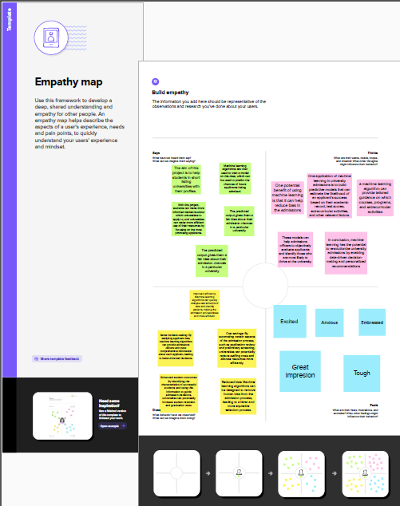

2.2 IDEATION AND BRAINSTROMING

Admissions prediction by using the brainstorm and ideation here are the some of the ideas

1.Collect and process the data

2.Feature selection

3.Algorithm selection

4.Model training

5.Model evalution

6.Deployment

7.Continous improvement

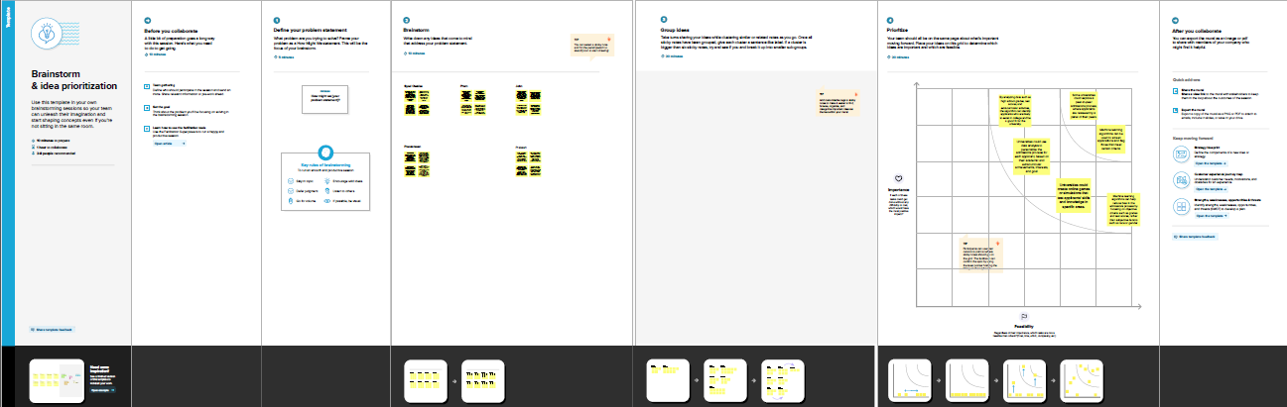

**RESULT**

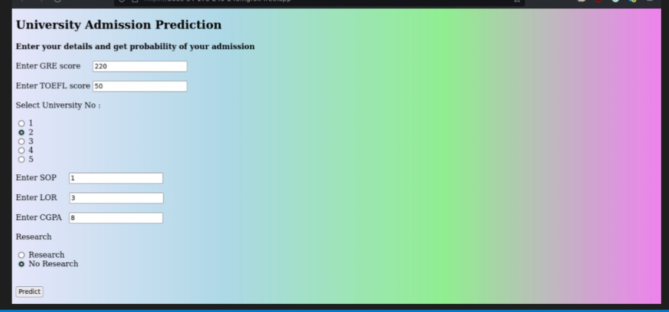

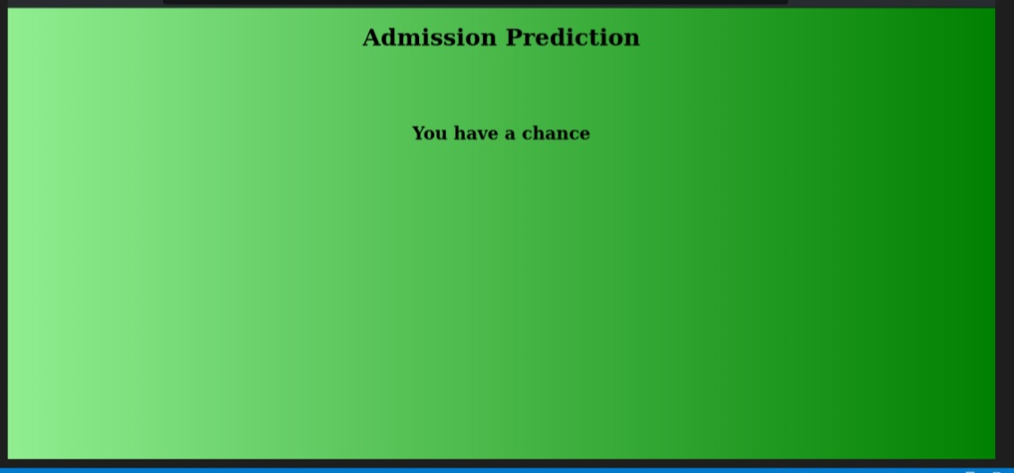

**SAMPLE CODING**

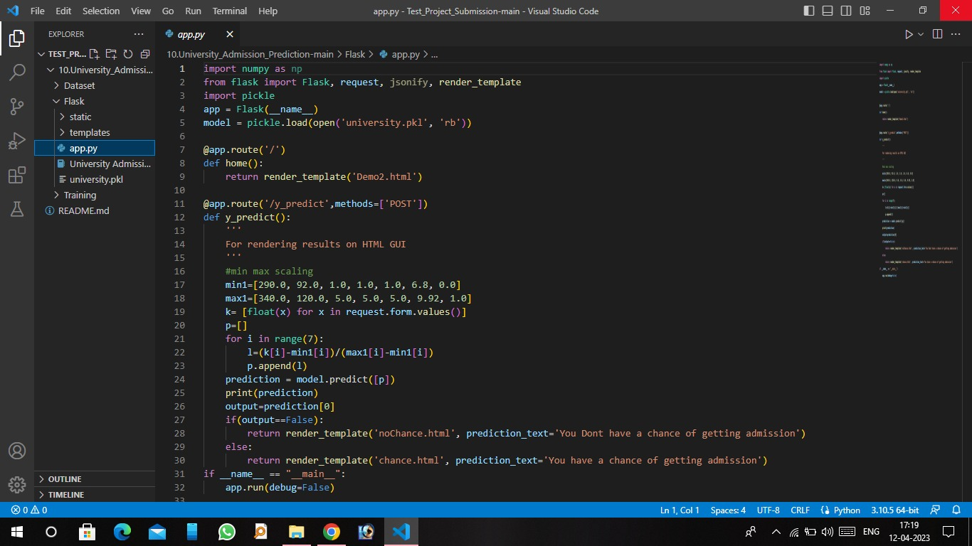

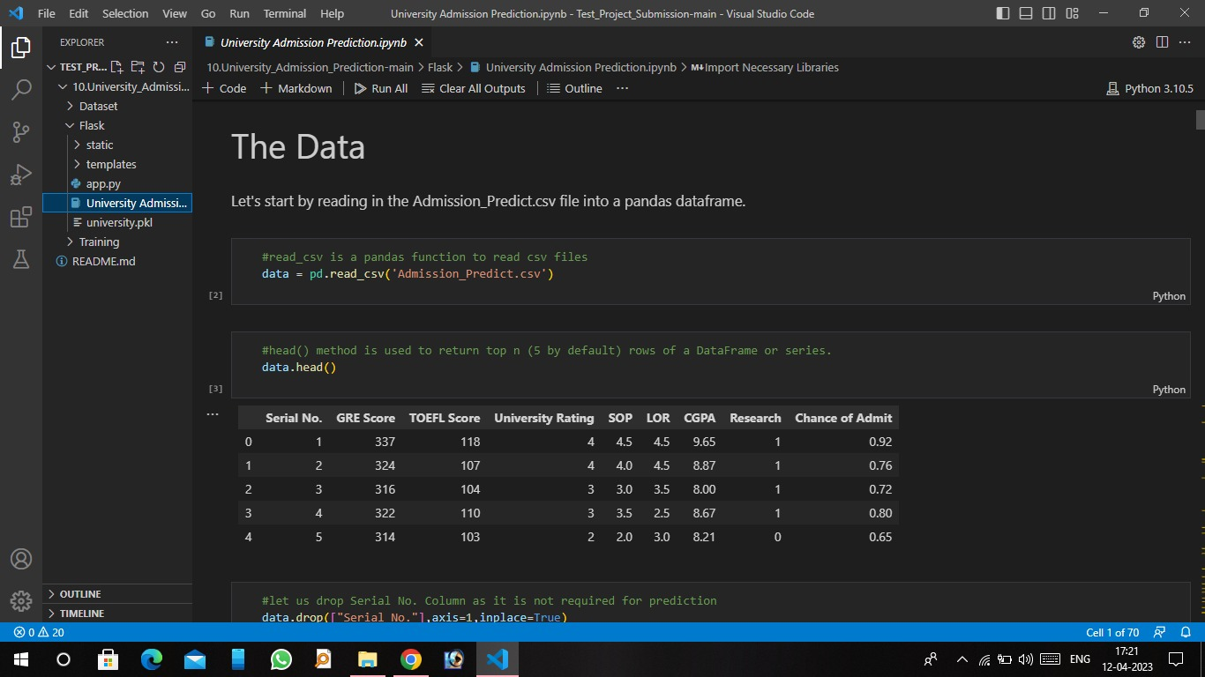

**ADVANTAGES**

His plan has the advantage of being less expensive than other options. He lacked the advantages of an advanced education. Speed is an advantage in most sports. The company's only advantage over the competition is its location.

The purpose of having a competitive advantage is to distinguish a company from its competitors by offering something different and of superior value to its customers. Competitive advantage also means the business can outperform its competition in the market and make a higher profit.One of the advantages of myelinating cultures is the ability to visualize axons that are only partially myelinated.

In contrast, a direct implementation benefits from all the advantages of developing in a highlevel programming environment.Permutation-free calculi have the advantages of a sequent calculus system, whilst reflecting the structure of normal natural deductions

verb (used with object), advantaged, advantaging. to be of service to; yield profit or gain to benefit to cause to advance; further; promote: Such action will advantage our cause. to prove beneficial to; profit: It would advantage him to work harder.

**DISADVANTAGES**

Absence or deprivation of advantage or equality. the state or an instance of being in an unfavorable circumstance or condition: to be at a disadvantage. something that puts one in an unfavorable position or condition: His bad temper is a disadvantage

An AMCAS statement of disadvantage is an optional short essay where students can explain any circumstances where they experience a disadvantaged situation or circumstance in applying to medical school.

Childhood disadvantage can affect cognitive functioning, cause neurological impairments, disrupt executive functioning (e.g., one's ability to plan and problem solve), and cause alterations in attention (inattention) and consciousness (Stikkelbroek et al., 2016), all of which are in turn associated with intellectual .

If you are at a disadvantage, you have a problem or difficulty that many other people do not have, which makes it harder for you to be successful. The children from poor families were at a distinct disadvantage.

Socially disadvantaged individuals are those who have been subjected to racial or ethnic prejudice or cultural bias within American society because of their identities as members of groups and without regard to their individual qualities

Disadvantages can help propel you to see your situation from different perspectives and find approaches to succeed that you might not otherwise have found.

**APLLICATIONS**

An application in a software program which enables you to perform a range of useful tasks. Examples of applications are word processing programs, spreadsheet software, databases or graphics packages.

Application areas are deployment-oriented categories that focus on commonly deployed ITS services or systems. Application areas provide a starting point for identifying the ITS standards and other resources (e.g., case studies, lessons learned) that may be relevant to a specific type of deployment.

Application software is usually distinguished into two main classes: closed source vs open source software applications, and free or proprietary software applications.

Software is a set of instructions, data or programs used to operate computers and execute specific tasks. It is the opposite of hardware, which describes the physical aspects of a computer.

Application-level analysis is about analyzing the data transmitted by an application as the application would have interpreted it. This is a resource-intensive type of analysis in several regards.

Application Unit means, in respect of a Listed Class, such number of Units of a Listed Class or whole multiples thereof as specified in this Prospectus or such other number of Units of a Listed Class determined by the Manager, approved by the Trustee and notified to the Participating Dealers.

**CONCLUSION**

The conclusion of this project is to help students in short listing universities with their profiles.

Machine learning algorithms are then used to train a model on this data, which can be used to predict the chances of future applicants being admitted.

With this project, students canmake more informed decisions about which universities to apply to, and universities can make more efficient use of their resources by focusing on the most promising applicants

.The predicted output gives them a fair idea about their admission chances in a particular university.

This analysis should also help students who are currently preparing or will be preparing to get a better idea.

**FUTURE SCOPE**

The future scope of Machine Learning will take this digital world to a new era of automation. In this blog, we will see the Machine Learning future scope.

The scope of Artificial Intelligence is limited to domestic and commercial purposes as the medical and aviation sectors are also using AI to improve their services. If AI is outperforming human efforts, then opting for AI automation will reduce costs in the long run for a business.

Various benefits of AI lead to various use cases and job roles in the market, which are beneficial for deep tech enthusiasts or freshers looking to build their careers in the AI industry. The scope of AI is bright in India as firms need expert employees who can extract meaningful information from large chunks of data

Positive Impacts of Artificial Intelligence on Human Society In the workplace, artificial intelligence can boost efficiency and increase humans' capacity to perform certain tasks. AI frees humans to do work they are better equipped for, such as creative and empathic tasks, by taking over repetitive or dangerous tasks.

Posted on July 24, 2022 · The scope of a study explains the extent to which the research area will be explored in the work and specifies the parameters within the study will be operating. Basically, this means that you

**APPENDIX**

**Intelligent Admissions : The Future Of University**

**VIDEO LINK ABOUT THIS PROJECT**